Julian Burgoff

12/7/2022

Analysis of Environmental Data

Lab 11

1. 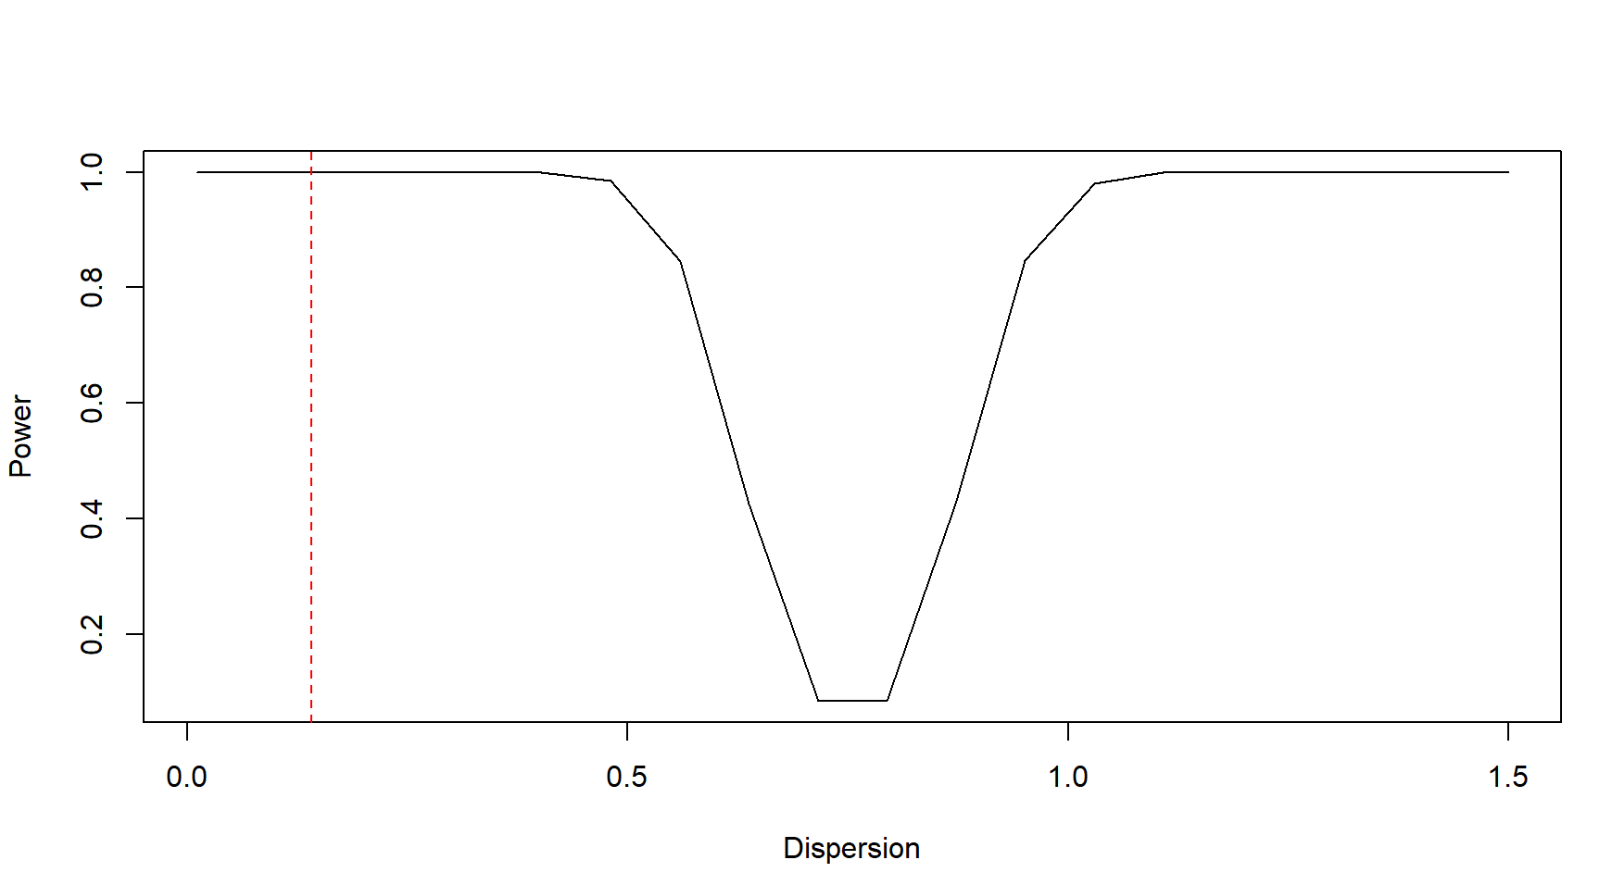
2. Smaller variance yields higher statistical power because with less variability in the data, relationships between dependent and independent variables become stronger and easier to detect.
3. Diagram

   Description automatically generated
4. When sample sizes are small and when population dispersion is high, statistical power is the lowest. In other words, there is a negative relationship between population dispersion and statistical power and there is a positive relationship between sample size and statistical power.
5. 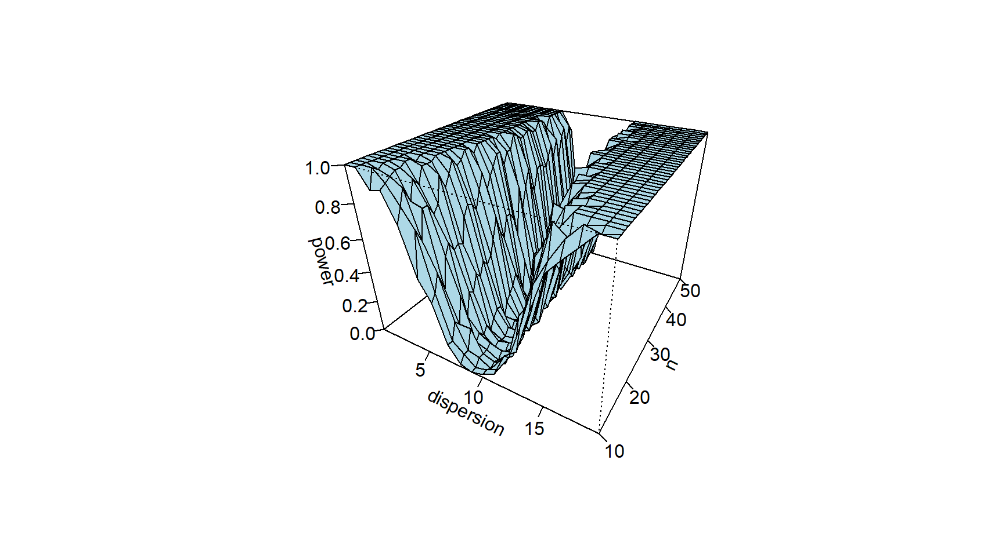
6. When designing an experiment, you could use information regarding the effects of variance and sample size to maximize statistical power. For example, if you have an idea about how much variance there is in your data, you can estimate the impact that additional sampling will have on statistical power. You can use this plot to forecast the strength of the inferences that you will be able to make given the variance and sample size of your data.